Exploratory Data Analysis Summary
FreshRetailNet-50K Working Subset
Derrick Nyagesuka | Data Preparation and Exploration | MIS 480-50 Predictive Analytics | October 15, 2026
Overview
This summary covers an initial look at our 9,000-row working subset (100 store-product series over 90 days, March 28 to June 25, 2024). The goal was to check whether the factors in our research question - promotions, discounts, holidays, stock availability, and weather - show enough variation and enough connection to sales to be worth modeling. Everything below is an association in the data, not a proven cause.
1. How daily sales are distributed
Daily sales are heavily right-skewed. Most store-product-days sell small amounts, with a long tail of higher-selling days. We may need to account for this skew when we model, for example with a log transform.
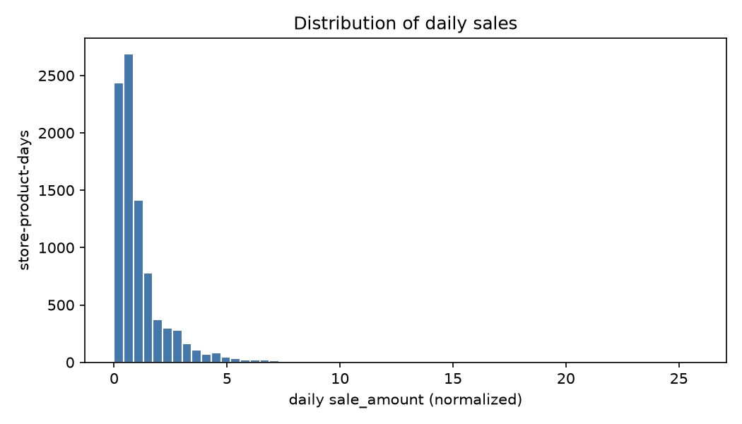
Figure 1. Distribution of daily sales across the subset.
2. Which conditions move sales
Discounts and holidays line up with the biggest jumps in sales. Discounted days sell about double non-discounted days (roughly 1.6 versus 0.8), and holidays show a similar lift (about 1.6 versus 1.0). Promotions show a smaller positive difference. Stockout days look higher on average here, but that number is misleading on its own - the stockout chart below shows why.
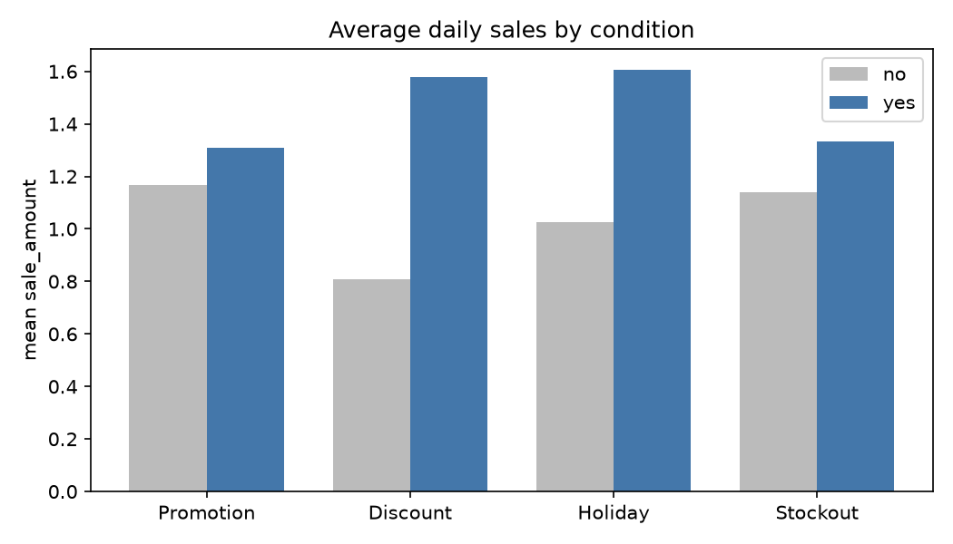
Figure 2. Average daily sales with each condition off versus on.
3. Sales across the 90 days
Average sales follow a clear weekly cycle, with regular peaks on weekends, plus a general rise into mid-May. This supports using a previous-week same-day baseline for forecasting. Ninety days is too short to say anything about annual seasonality.
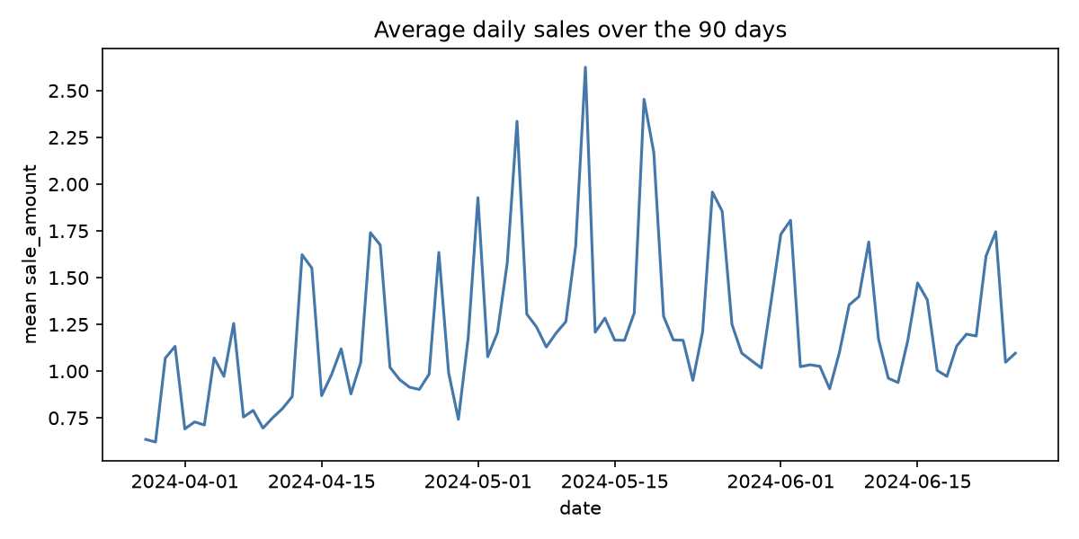
Figure 3. Average daily sales over the 90-day window.
4. Sales and temperature
Sales rise with temperature, from about 0.85 in the coolest range to about 1.39 around 22 to 24 degrees, then flatten out. Weather matters, but less strongly than discounts or holidays.
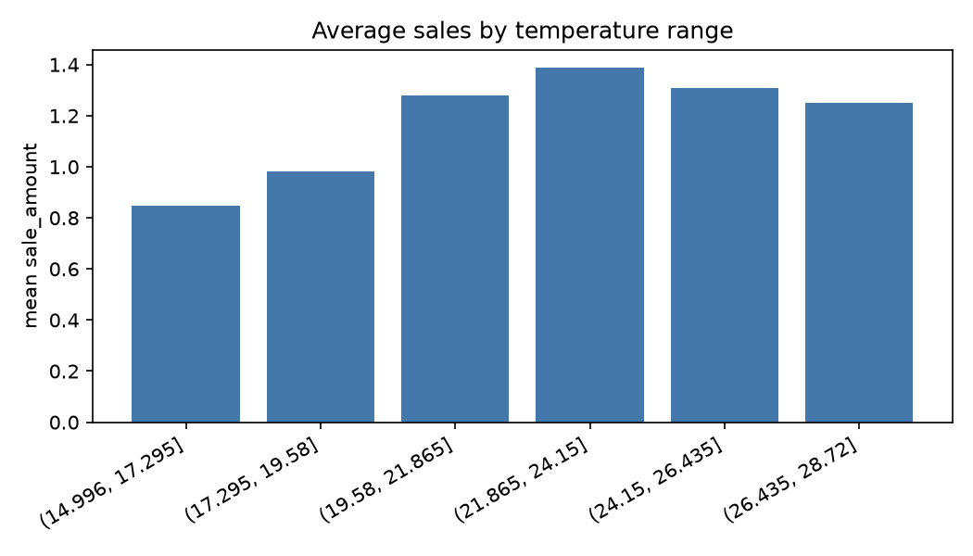
Figure 4. Average sales by temperature range.
5. Stock availability (the key finding)
The relationship between stockouts and sales is not a straight line. A few out-of-stock hours (1 to 3) actually show the highest observed sales, because the popular, fast-selling items are the ones that briefly run out. But as out-of-stock hours climb, observed sales fall sharply - down to about 0.46 for days with 12 or more out-of-stock hours. That low number is not low demand; it is demand that went unmet because the product was unavailable for most of the day. This is the main reason we cannot treat low sales as low demand, and why we plan to separate observed sales from demand lost during stockouts.
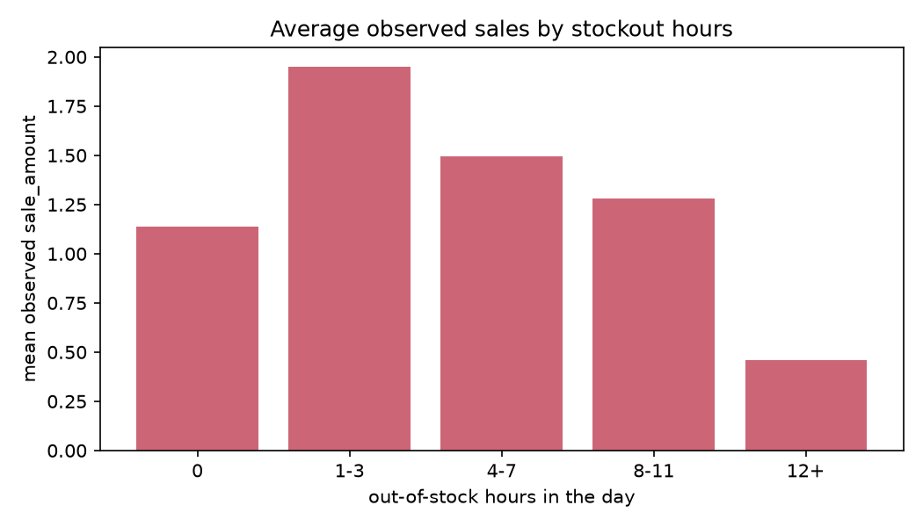
Figure 5. Average observed sales by number of out-of-stock hours.
What this means for modeling
- Day of week is a strong, usable signal, which supports a previous-week same-day baseline.
- Discount and holiday are the strongest demand levers; promotion and temperature are weaker but still informative.
- Stockouts need special handling so heavy-stockout days are not read as genuine low demand. The full hourly stock data is in the subset parquet file.

